Name : Abdul Rehman Section :B

Course : CCN Roll No : CT-22052

---------------------------------------------------------------------------------------------------------------------

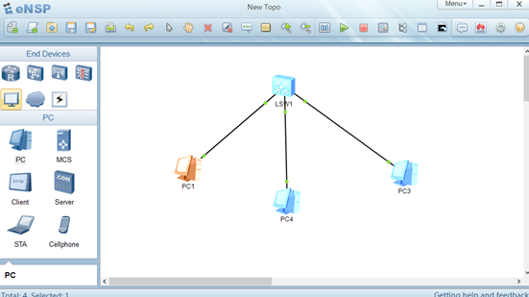  
  
  
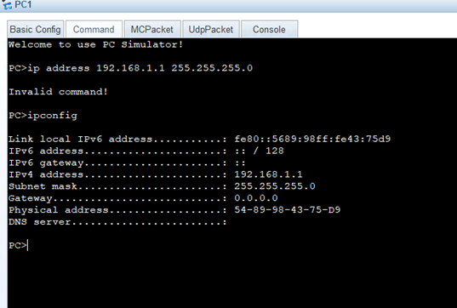

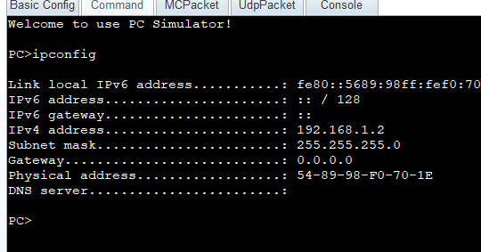  
  
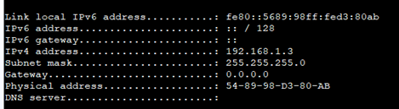  
  
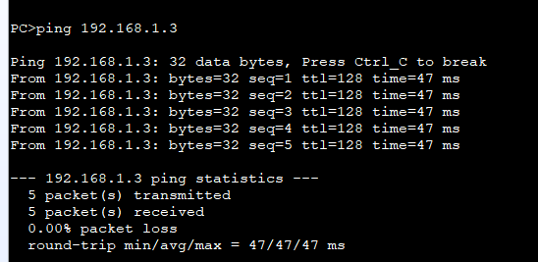  
  
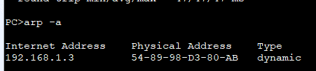  
  
The ARP table stores IP-to-MAC address mappings to help devices communicate in a network. When a device (e.g., PC1) wants to send data to PC2, it checks its ARP table. If PC2’s MAC address is missing, PC1 sends an ARP request, and PC2 replies with its MAC address, updating the table. PC2 also maintains its own ARP table and responds to requests. There are two types of ARP entries: Static ARP (manually set and permanent) and Dynamic ARP (automatically learned and temporary). Static entries stay fixed, while dynamic ones expire if unused.